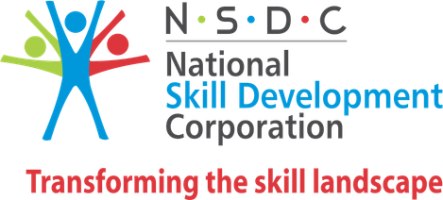 SKILL INDIA 

CERTIFICATE OF COMPLETION
PEOPLE SKILL


IN : course of advance excel
Awarded to :xxxxxxxxx
At :synergy,mayiladuthurai,kamarajar salai
During :26-mar-2024 - 02-may-2024 Student ID : CO24326Z968631

UMAMAGESHWARI SIVASUBRAMANIYAN 03-MAY-2024
MANAGING DIRECTOR CENTRE HEAD DATE OF ISSUE

This is a computer generated certificate.for more details ,please verify at http.synergysbs.com/student_verification.php

Synergy school of business skills,training is available through wide network of training centres the courses offered are comprehensive and of high quality the participants are trained by well experienced instructors using tools & technology synergy & synergy logo are registered trademarks of CADD Centre .


Corporate Office:
1 St Floor No 25 Dr Radhakrishnan Salai Mylapore,
Chennai 600004 Tamil Nadu India
www.synergysbs.com
STUDENT NAME: XXXXXXXXXXX .

STUDENT ID NO : CO24326Z968631

Microsoft excel advanced
Custom and conditional formats
Data validation
Advance table operation
Array function
Using formulas and function
Working with charts
Working with pivot tables
What if analysis
Working with macros

Synergy uses legal software from the above software developments synergy student are employed in many companiens and universities in serveral countries worldwidesynergy and synergy logo are registered trademarks of CADD centre training service private limited all brand name and trademarks belong to respective owners

PMIS | ORACLE | MICROSOFT OFFICE | SAP | SCRUM Study | KAIZEN | TALLY

The PMI authorized training partner logo is a registered mark of the project management institute Inc

